A Comparative Analysis with python & Java in OpenSource Development

Course Name: Programming with Python (DLMDSPWP01)

Course of Study: Msc Computer Science On-Campus

Type of Thesis: Research & Practical

Author Name: Husna Sanuber

Author Email: husna-sanuber.na@iu-study.org

Matriculation Number:4244067

Tutor Name: Cosmina Croitoru and Tai Le Quy

**Tables on content:**

**1.** Introduction

2 Development Speed and Flexibility

2a. Rapid Development:

2b. Compiling and Verbosity

3. Library and Framework Availability

3a. Extensive Libraries

3b. Established Libraries

4. Community Engagement and Support

4a. Dynamic and Inclusive Community

4b. Corporate and Academic Influence

5. Learning Curve and Accessibility

5a. Beginner-Friendly:

5b. Steeper Learning Curve:

6. Adoption in Emerging Fields

6a. Leader in Innovation

6b. Enterprise Focus

7. Conclusion

8. References

9. Appendix

**INTRODUCTION**:

**What is Python?**

High-level programming languages, like Python, are designed to be easy to read and write. Python was made by Guido van Rossum and came out in 1991. Its simple and clean code makes it good for both beginners and experts. Python can be used in different ways, such as for automation, data analysis, making websites, and artificial intelligence. It has many libraries and tools that make it useful for a lot of different tasks.

History of Python:

Guido van Rossum developed Python in the late 1980s, and it was initially made available in 1991. Python was created by Guido to replace the ABC programming language, with the goal of addressing some of ABC's drawbacks while preserving its advantages. Because of the language's easy-to-read and write nature, programming is now more accessible. Python's ease of use and adaptability led to its rapid rise in popularity. It changed over time, gaining new features and enhancements with each new iteration. With the release of Python 2.0 in 2000, significant features including garbage collection and list comprehensions were included. With the release of Python 3.0 in 2008, significant modifications were made to the language to enhance consistency and eliminate outmoded features. Despite the fact that Python 2 and Python 3 were frequently used together.

**What is Java?**

Java is a computer language that Sun Microsystems released in 1995. You can write code once and run it anywhere since it's made to be simple to use on any hardware or operating system that supports the Java Virtual Machine (JVM). Java is widely used to create a variety of applications, such as enterprise-level corporate software, mobile apps, and websites. It is regarded for being quick, safe, and stable. The syntax of the language is similar to those of C and C++, but it is less complicated because it manages complicated operations like memory on its own. For developers, Java is much more potent and versatile because to its vast array of tools and frameworks.

**What is Open Source?**

OpenSource Software that has its source code turned Opensource means that everyone can access, alter, and distribute it without restriction. Because users may inspect the code to learn how the program functions and make sure there are no unreported problems, this method promotes transparency. Improvements and innovation are accelerated by the collaborative development of opensource software by a global community of contributors. It's also economical for both individuals and corporations because it's usually free to utilize. Another significant benefit is the software's ability to be easily modified and customized to meet unique requirements. Furthermore, a largecommunity review and input often result in a quickerdiscoveryand fixing of security flaws. The Linux operating system is one example of open source software.

* **Opensource offers several key benefits:**

Opensource software is typically free to use, both people and corporations can save a lot of money. It's an affordable option as there are no subscription fees or license fees.

Opensource software is available to everyone as source code. Because of its transparency, users can be sure there are no hidden features or security issues in the software and can understand how it operates.

Opensource software can be customized by users to fit their own requirements. This flexibility enables modification and the creation of specially designed solutions that more effectively satisfy certain needs.

Global user and developer community contributions are typically very beneficial to Opensource projects. This cooperative setting promotes creativity, raises the caliber of software, and quickens development.

Security flaws are often found and fixed more quickly when multiple developers are examining and enhancing the code. The collective examination contributes to the increased security of Opensource software.

Software can become more dependable and stable as a result of constant testing and feedback from a large user base. Support from the community frequently speeds up problem solving and improves performance overall.

There are many worthwhile learning possibilities using Opensource software. By participating in actual projects, developers can get experience, understand best practices, and analyze the code.

Using Opensource software lessens reliance on a single supplier. Users have more freedom and control over the technology they choose because they are not restricted to using the goods or services of a particular corporation.

**Comparative Analysis with python & Java in Open Source**

**1. Development Speed and Flexibility**

Python

* Python's interpreted programming language facilitates rapid feedback and iterative development, which dramatically improves the development process. Python is an interpreted language, thus developers don't need to wait for a long build process to execute and test code snippets. Because it allows for quick experimentation and troubleshooting, this immediacy aids in accelerating development. It works well with agile development methodologies, which place a strong emphasis on numerous iterations and ongoing improvement. Developers may more readily modify and improve their work when they receive immediate feedback on changes to the code, which promotes a more adaptable and effective development cycle. During development, this capacity is very helpful for prototyping and making last-minute changes.
* Python's dynamic typing allows for more coding freedom while minimizing repetitive code. Compared to languages with statically typed syntax, this enables developers to complete the same tasks with less code.
* The extensive Python standard library includes modules for a wide range of applications, including file handling, networking, data serialization, and cryptography. This vast array of integrated tools simplifies development and reduces the need for third-party libraries.

Java

* Compilation can be a bottleneck in Java development, particularly in the iterative stages of building and testing. Before testing or executing the program, the code needs to be recompiled after every modification. Due to the fact that developers must wait for the compilation process to finish before seeing the effects of their changes, this can be time-consuming and disrupt progress. Recompiling frequently can be a major obstacle, especially in agile or fast-paced development environments where it's critical to receive feedback quickly and make quick iterations.
* In Java, static typing can lead to more verbose code even while it offers robustness and error checks. The verbosity in the code might hinder development and increase maintenance costs.
* Java frameworks such as Spring often require extensive configuration, which can increase development time and complexity, especially for smaller or experimental projects

**2. Library and Framework Availability**

**2a. Extensive Libraries**

* One of the biggest repositories for open-source packages, PyPI (Python Package Index) has more than 400,000 libraries and utilities. Nearly every need is covered by this enormous collection, including networking, data analysis, web frameworks, and automation**.**
* Python provides a wide range of specialized tools for various tasks. Django is a powerful framework for web development that has a ton of built-in functionality, which makes it ideal for big, intricate websites. Contrarily, Flask is easier to use and more adaptable, making it ideal for smaller projects where greater control is required. While PyTorch is more user-friendly and preferred in research, TensorFlow is a robust tool for deep learning in machine learning and is frequently utilized in large applications. Each is widely accepted and necessary for anyone involved in data science or artificial intelligence.
* Because of Python's libraries' high degree of interoperability, developers can combine several tools to construct complex applications that are suited to their particular needs. One of Python's biggest assets is its interoperability, which allows programmers to take advantage of each library's best features. For instance, a developer may combine TensorFlow for machine learning capabilities, use SQLAlchemy for database administration, and create a lightweight web API using Flask—all within the same project. In addition to accelerating development, this modularity promotes experimentation and facilitates idea prototyping, iteration, and refinement. As the project develops, developers may easily replace or add new components without having to start from scratch. Python's popularity across a variety of domains, including online
* .

**2b**. **Established Libraries**:

* Maven Central, which offers a wide range of libraries and tools, is in charge of managing the Java library ecosystem. Maven Central is vast, but because of all the dependencies and potential version conflicts, it can be hard to navigate.
* Although strong Java frameworks such as Spring and Hibernate require a lot of setup and configuration to get going, they might be complicated to use. They may become more difficult to utilize as a result, particularly for small teams or when beginning a new project. The intricate setup needed can impede work and make things go slowly. For individuals who are unfamiliar with these frameworks, their complexity may be daunting, and it can hinder productivity. Smaller teams may therefore find it difficult to strike a balance between the time and effort needed to build up the frameworks and the need for their capabilities.
* There are numerous outdated libraries and frameworks from earlier eras in the Java ecosystem. Even while these technologies may not necessarily align with contemporary development methodologies, they are valuable for maintaining the functionality of older systems. Even though they don't use the newest trends or technology, they aid in making sure that ongoing initiatives continue to function well. Because it enables companies to preserve their current software without having to start from scratch, support for outdated systems is crucial.

**3**. **Community Engagement and Support:**

Python

**3a**. **Dynamic and Inclusive Community:**

* The Python community is both large and diverse, including individuals from businesses, educational institutions, and various other sectors. This broad involvement brings together a wide range of ideas and perspectives, which helps keep the language innovative and up-to-date. The community's active participation contributes to Python's continuous evolution, fostering creativity and ensuring that the language remains relevant and useful for a variety of applications.
* Developers of different skill levels get together for conferences such as PyCon, DjangoCon, and SciPy to collaborate, exchange ideas, and move the language forward.. These are fantastic opportunities to network and learn.
* Users can collaborate to solve problems, exchange expertise, and ask for assistance on websites such as Stack Overflow
* The Python community is well-regarded for its strong mentoring and support networks.
* The Python Software Foundation (PSF) provides assistance with a wide range of tasks, including funding community events, endorsing open-source initiatives, and advancing education. This maintains Python's growth and user-friendliness.

Java

**3b. Corporate and Academic Influence:**

* Java’s community and ecosystem are significantly molded by by large companies like Oracle and IBM which play a big role in sponsoring and contributing to numerous Java projects. This influence can sometimes make the environment feel more formal and less approachable.
* Java is a popular academic programming language, particularly in classes on computer science. This gives you a good foundation in Java, but in comparison to Python, it can also make community involvement less organic and more formal.
* Professionals can interact and learn through Java user groups (JUGs) and conferences like JavaOne, which offer a wealth of networking and instructional possibilities. But in contrast to the more relaxed get-togethers that are frequently observed in the Python community, these meetings are frequently more formal and planned. Consequently, novices or people unfamiliar with the Java environment may find the formal atmosphere uninviting or unapproachable, making them feel less welcome.

**4. Learning Curve and Accessibility:**

**4a. Beginner-Friendly**

* Python's syntax is simple and easy to understand. This makes it a great language for beginners to learn programming. For example, Python uses indentation to show code blocks instead of extra symbols, which makes the code clearer and easier to read.
* New developers can benefit immensely from the wide range of learning tools that Python offers. Extensive documentation makes it simple to get information and solve problems by covering everything from basic syntax to complex subjects. Interactive lessons provide practical experience and hands-on practice, enabling learners to apply concepts in real-time. Furthermore, learning environments such as Coursera and Codecademy provide students with structured courses that walk them through Python programming using real-world exercises and projects. Together, these resources help novices better understand complicated ideas and learn at their own pace. New developers can gain a solid foundation in Python programming and expedite their learning experience by utilizing these tools.
* Python’s community offers plenty of help through forums, Q&A sites, and educational content. This support system helps beginners solve problems and improve their skills.

**Java**:

4b. **Steeper Learning Curve**

* Java has a more complex syntax that calls for additional code and the specification of data types. This may make it more difficult for newcomers to comprehend programming ideas and produce effective code.
* Java is frequently taught in formal academic environments, which aids in students' comprehension of the language's core ideas. But this conventional method does not necessarily give novices the practical, hands-on experience they need to apply their information efficiently. Academic courses may include core concepts and theoretical features, but they might not include interactive exercises and real-world projects, which are essential for honing practical skills and getting a deeper grasp of Java's application in real-world programming settings.
* Learning Java becomes more challenging due to its focus on object-oriented programming, Despite their strength, these ideas can be challenging for novices to understand.

**5. Adoption in Emerging Fields:**

**5a. Leader in Innovation**

* Python has emerged as the top language in machine learning and data research. It's highly helpful because of libraries like Matplotlib, which is used to create charts and graphs, and Pandas, NumPy, and SciPy, which aid with data analysis. It is now simpler to handle and comprehend data with these tools.
* Web development has undergone significant transformation thanks to Python frameworks like Django and Flask, which provide high-level abstractions that streamline the procedure. Django offers a feature-rich framework with all the components required to rapidly develop reliable online applications. In contrast, Flask is lightweight and adaptable, enabling developers to include only the components that are necessary. Both frameworks are renowned for their effectiveness and usability, which makes it easier and faster for developers to create online applications. Both novice and seasoned developers can benefit from these technologies since they simplify the management and scaling of projects.
* Python is a highly preferred language among scholars and researchers due to its strong scientific computing capabilities. Its broad library support, which includes programs like Pandas, SciPy, and NumPy, offers crucial capabilities for intricate mathematical calculations and data analysis. The accessibility and simplicity of Python also make it suitable for scientists and researchers with limited programming experience. It is also a flexible instrument with a wide range of scientific applications due to its ability to integrate with other technologies. All things considered, Python's robust ecosystem and approachable design make it a great option for resolving complex scientific issues.

Java

**5b. Enterprise Focus**:

* Although Java hasn't made as much progress in emerging fields like data science and machine learning, it's still a viable option for backend systems and large corporate applications. Although there are some libraries available for Java in these disciplines, they are not as widespread or well-liked as those for Python. Data science and machine learning libraries in Python are more popular and have seen greater development. Python is now a more common option for these kinds of jobs as a result. Java works best in server-side and conventional commercial applications.
* Java's strong standing in business settings, legacy systems are frequently maintained and enhanced. For established corporate operations, this emphasis on stability and dependability is advantageous. It may, however, restrict Java's uptake in more recent and quickly developing domains. Java may hence not be as widely employed in developing technological fields. Sometimes, the focus on legacy systems results in a lack of attention to developments and trends in more recent technologies. This may have an impact on Java's adaptability and advancement in innovative fields.

**Real world example Explaining both Python and Java open source:**

**Example 1:** we need to open a large text file and collect each line into sets of 50 comma-separated records:

In Python

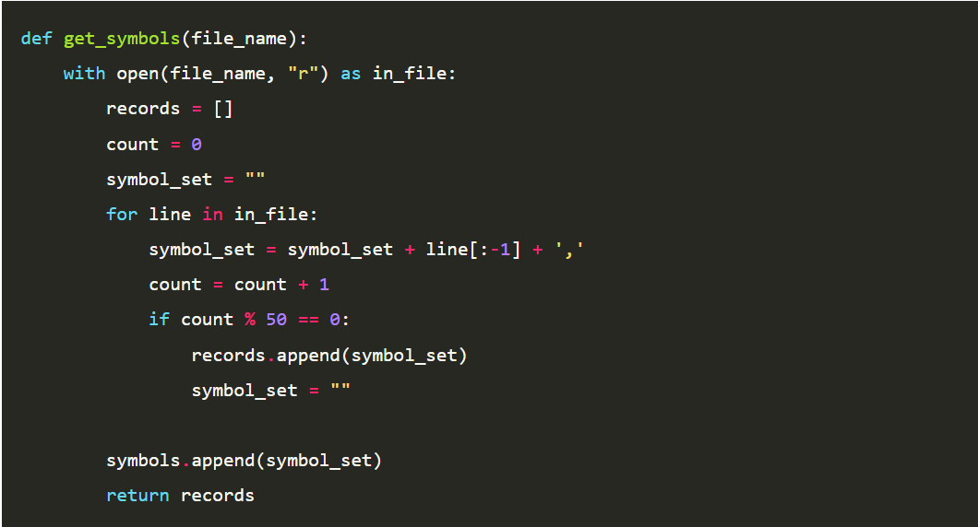

**In java:**

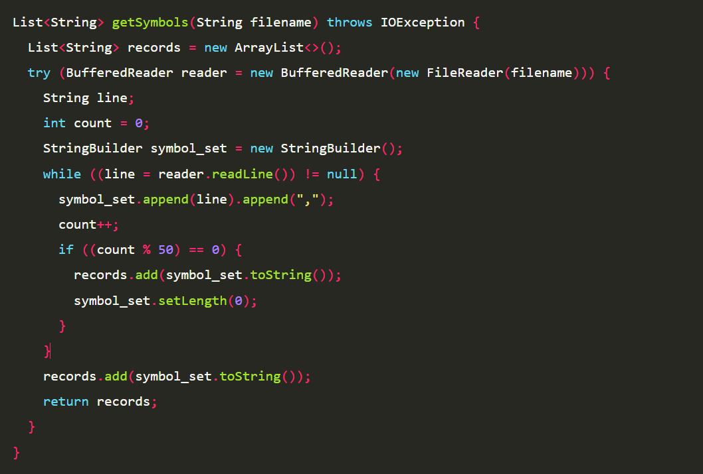

**Example 2**: how the two languages handle files

**In Python**



**In Java**



**Example 3**: create an array with some data in it, and print it

**In Python**

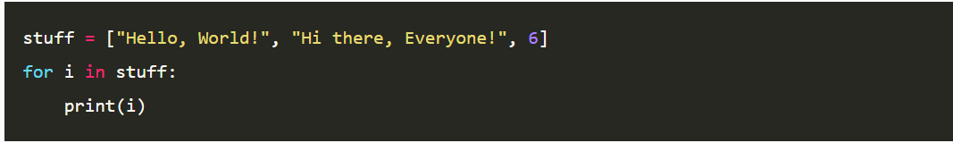

**In Java**

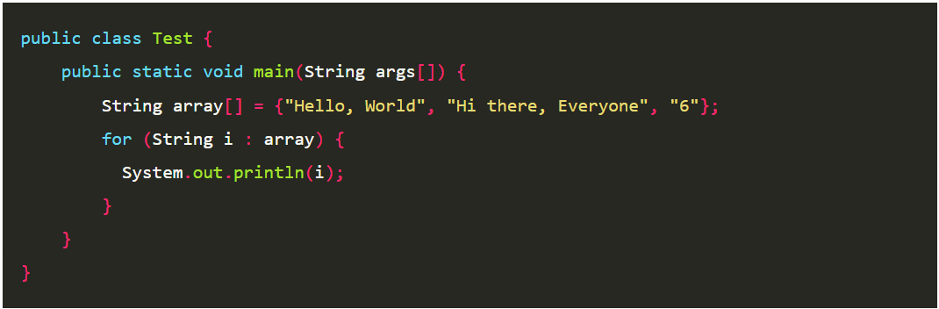

**Conclusion:**

Python is a standout in the open-source world for several reasons. First, it has a large and supportive community that helps new users and contributes to its development. This means that if you run into problems or need help, there are plenty of people ready to assist. Python also allows developers to create programs quickly because of its easy-to-read code and straightforward syntax. This makes it a popular choice for new programmers who are just starting out.

One of the key strengths of Python is its vast collection of libraries. Libraries are pre-written pieces of code that make it easier to perform common tasks. For example, if you’re working on a project related to data analysis, you can use libraries that provide ready-made functions for handling and analyzing data. This saves a lot of time and effort because you don’t have to write all the code from scratch.

Python is also very effective in modern fields like data science, machine learning, and scientific research. Data science involves analyzing large amounts of data to find useful information. Machine learning is a type of artificial intelligence where computers learn from data to make predictions or decisions. Scientific research often requires complex calculations and data processing. Python’s tools and libraries make it easier to work in these areas, which is why it is highly valued in these fields.

In contrast, Java is another popular programming language that is often used in enterprise environments and for backend systems. Backend systems are the parts of software that handle data and perform tasks behind the scenes. Java is known for its stability and scalability, which means it can handle large systems and keep running smoothly even as they grow. However, when it comes to innovation and accessibility in fields like data science and machine learning, Python often has the edge. This is because Python is designed to be easy to use and adapt quickly to new technologies and trends.

Overall, Python’s combination of being user-friendly, having a rich set of libraries, and its ability to keep up with new technological advancements makes it a leading language in the open-source community. It is not only a great choice for beginners but also a powerful tool for professionals working in cutting-edge fields.

**REFRENCES:**

1. **Raygun. "Java vs Python: Code Examples and Comparison." *Raygun Blog*, https://raygun.com/blog/java-vs-python/. Accessed 7 Sept. 2024.**
2. **Coursera. "What Is Python Used For? A Beginner's Guide to Using Python." *Coursera*, https://www.coursera.org/articles/what-is-python-used-for-a-beginners-guide-to-using-python. Accessed 7 Sept. 2024.**
3. **Oracle. "What Is Java?" *Java.com*, https://www.java.com/en/download/help/whatis_java.html. Accessed 7 Sept. 2024.**
4. **Red Hat. "What Is Open Source?" *Opensource.com*, https://opensource.com/resources/what-open-source. Accessed 7 Sept. 2024.**
5. **Rishani, YNR. "Python vs Other Programming Languages." *Medium*, 12 Dec. 2019, https://medium.com/@rishani.ynr/python-vs-other-programming-languages-a4763c8ff056. Accessed 7 Sept.**
6. **Alfried, Itamar Turner-Trauring. "Low-Level Python: Writing Fast C Extensions." *Python Speed*, https://pythonspeed.com/products/lowlevelcode/. Accessed 7 Sept. 2024.**
7. **Netguru. "Python." *Netguru*. Accessed September 7, 2024. https://www.netguru.com/glossary/python.**

**9. APPENDIX**

**9A. Code**

**. run the database file first then assignment file will work.**

**. github link :**

**Database.py**

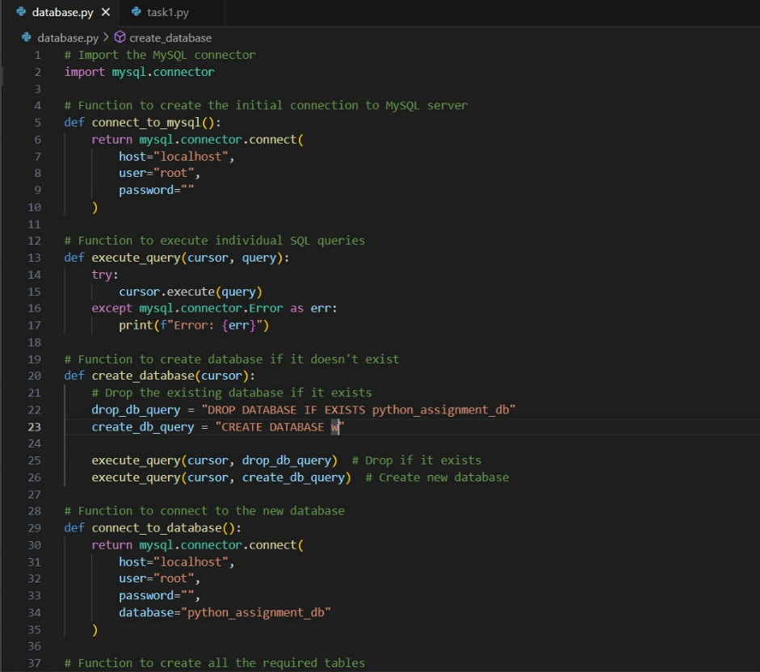

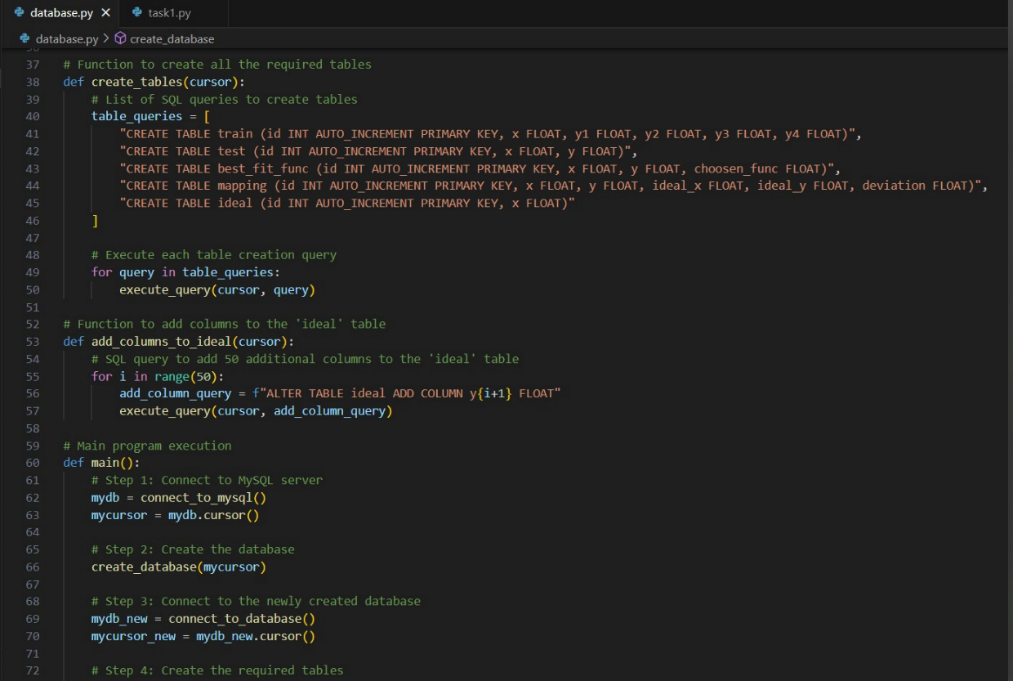

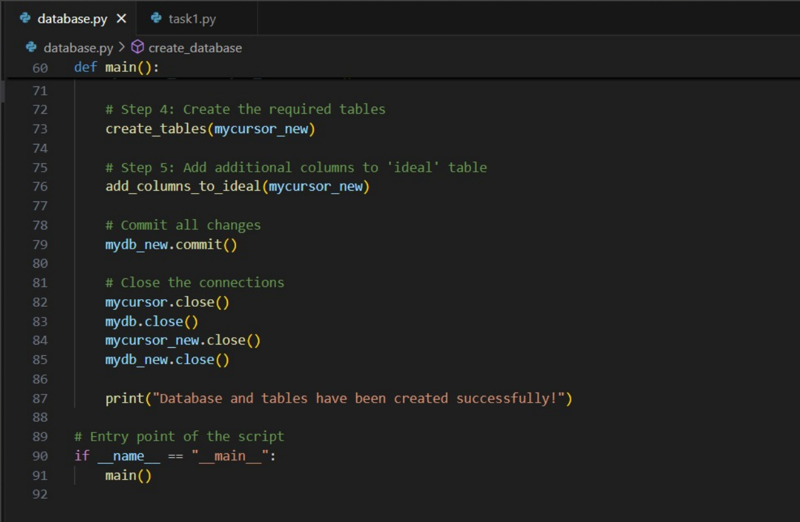

**Assignment.py**

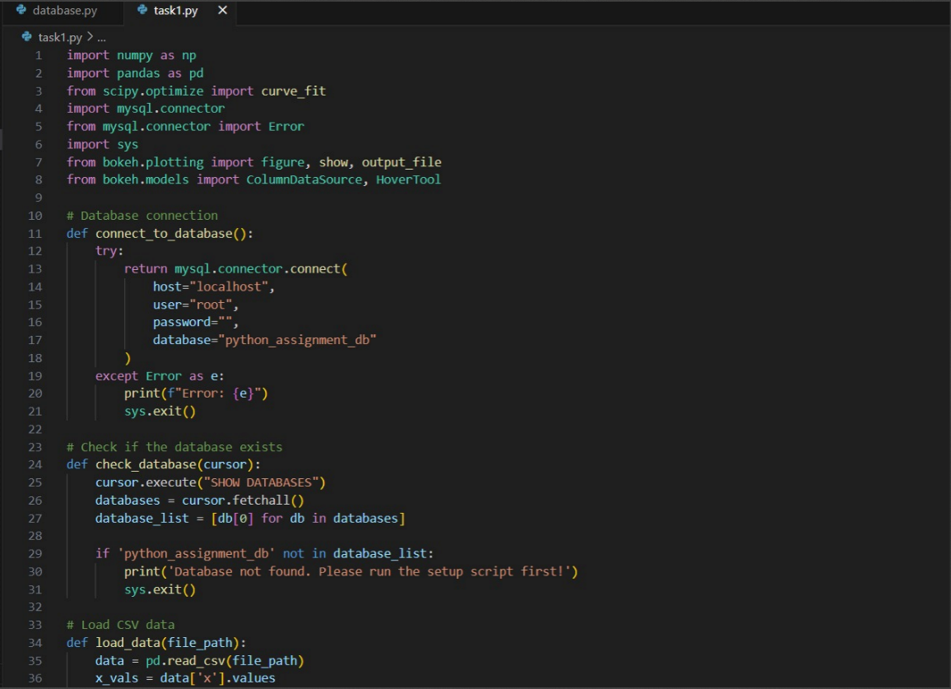

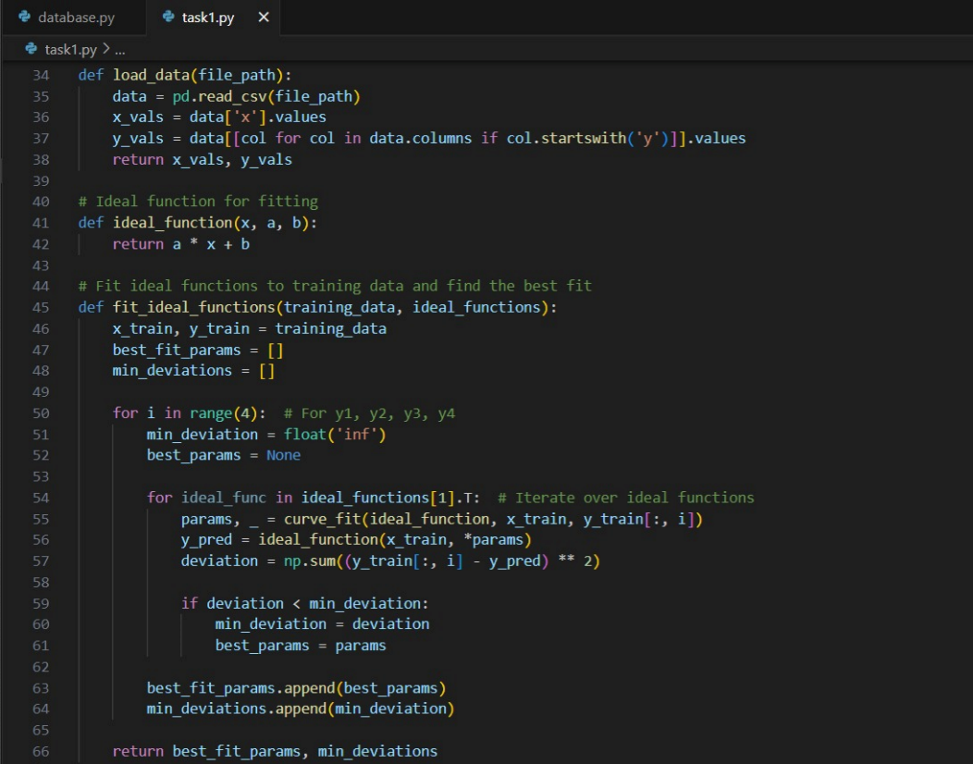

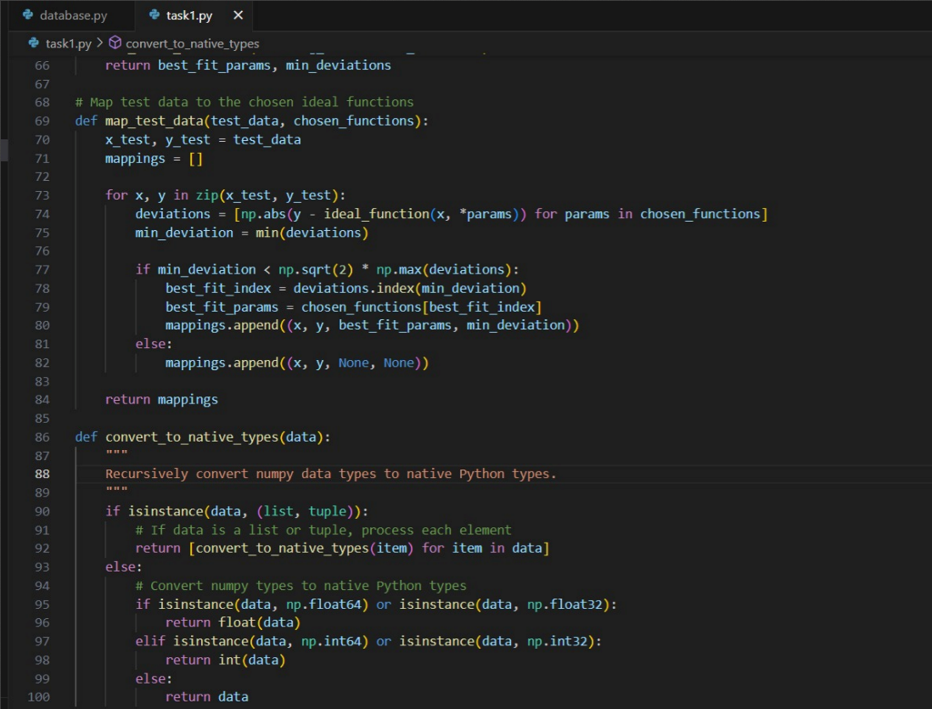

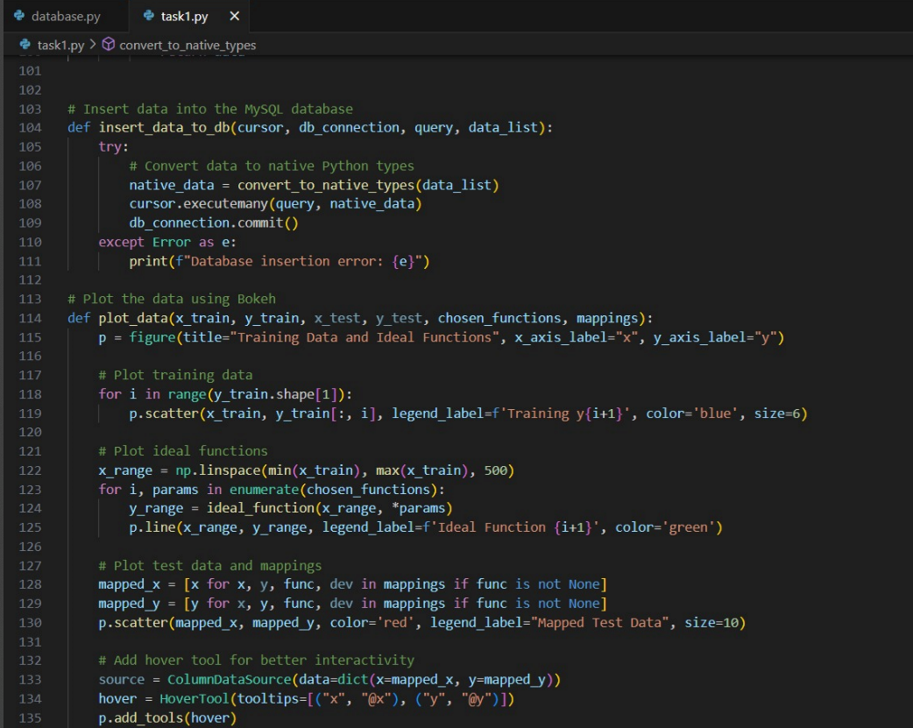

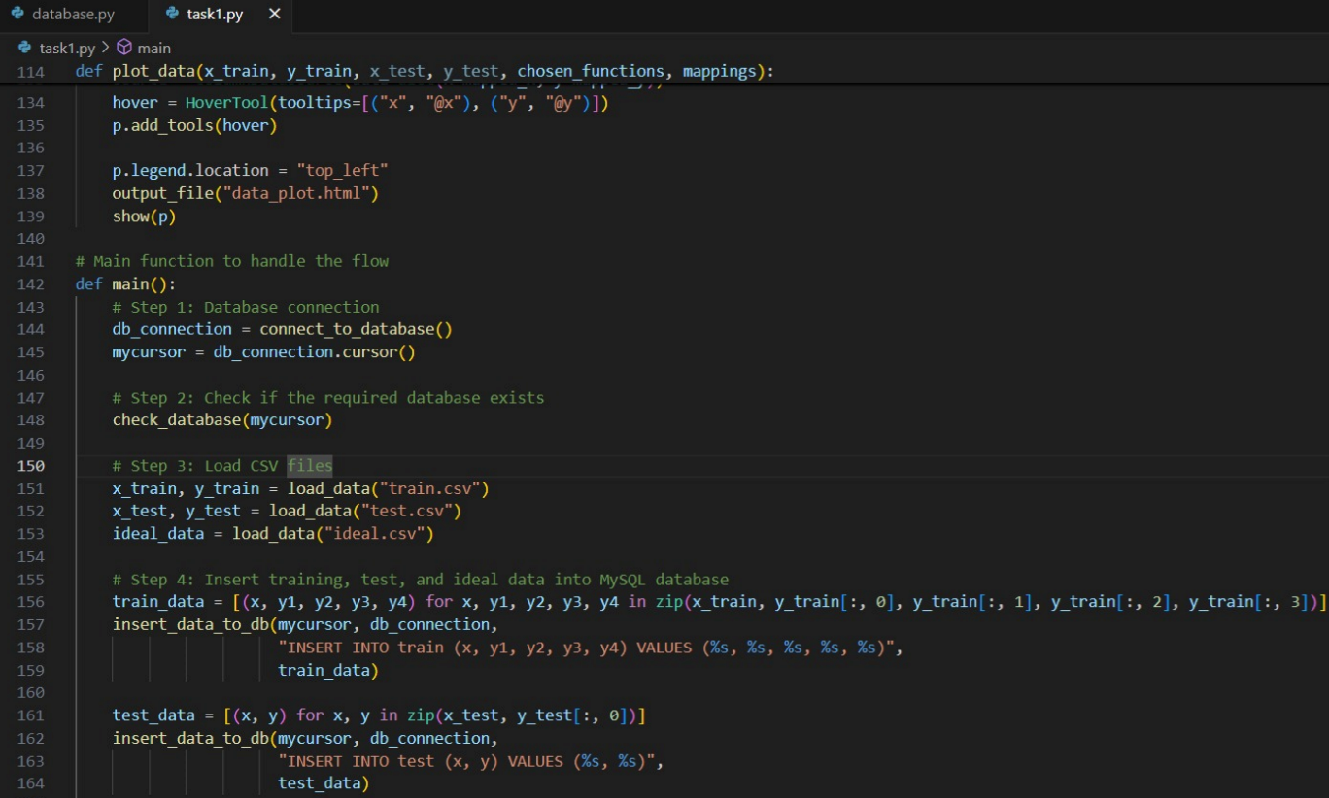

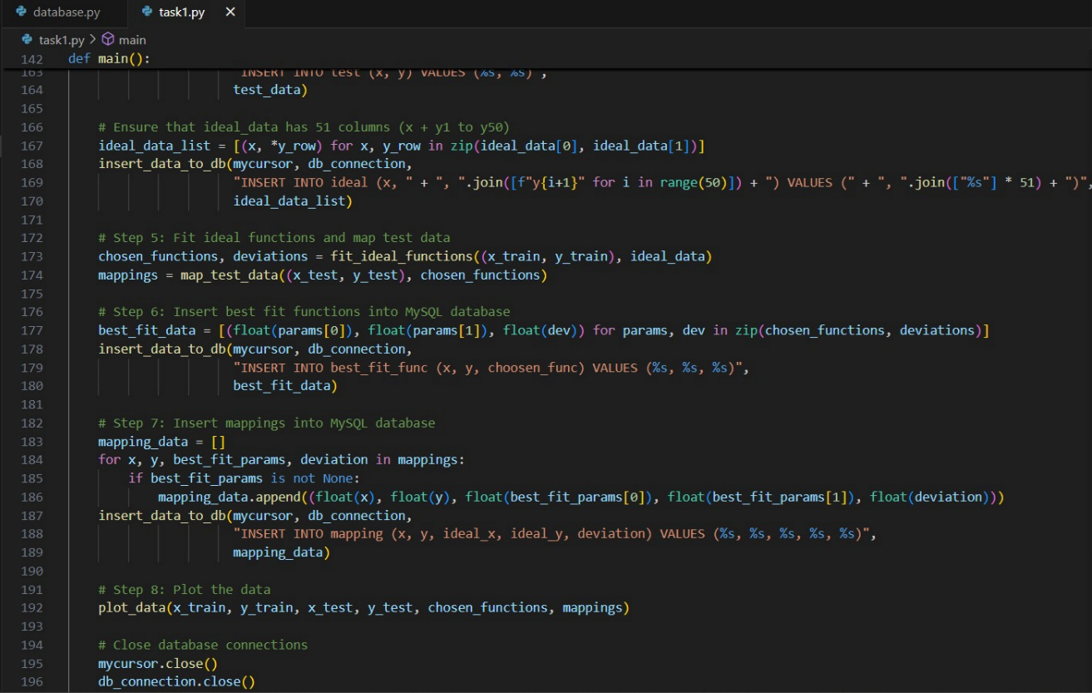

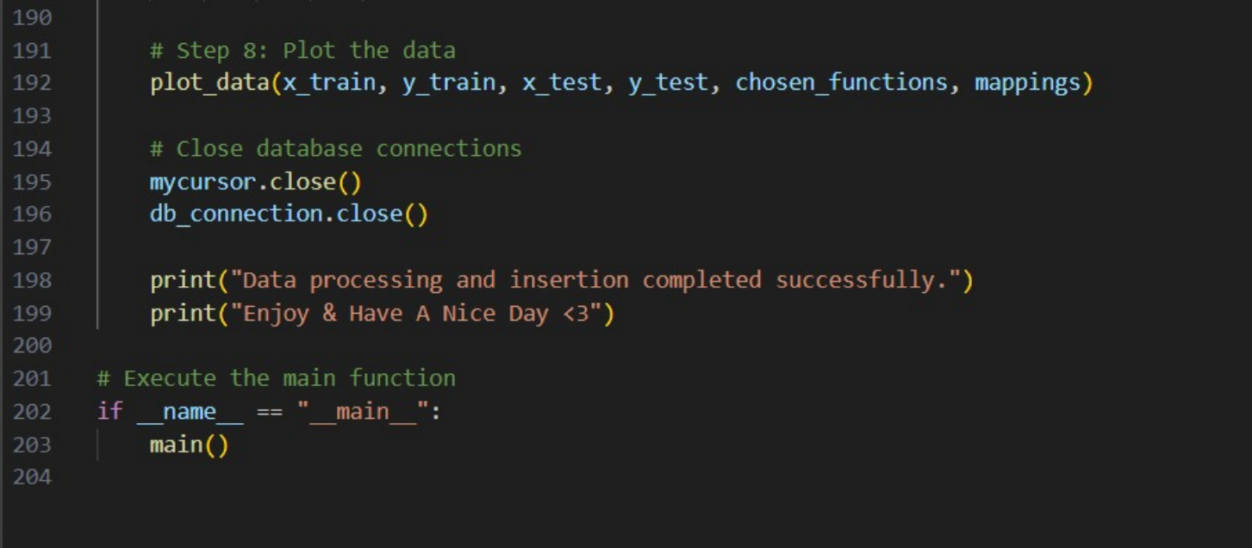

Result:  
  
